Review Descripciones
Google doc: https://docs.google.com/document/d/14NJ9jLT0JlaX0BNwP3E0QSxaw8DMx-B0wEfqnIkx_9s/edit?usp=sharing
Vocabulario:
Rubio Moreno Bajo Alto Gordo Delgado
Blonde Brunette Short Tall Fat Slim
Viejo Joven Amable Sociable Bonito feo
Old Young Kind, nice Sociable Pretty Ugly
__________________________________________________________________________
Masculine adjectives often end in –o Feminine adjectives often end in –a
Example: ALTO Shaq es alto. (boy) Señora White es alta. (girl)
BAJO Juan es bajo. (boy) Señora Harsha es baja (girl)
FEO Frankenstein es feo. (boy) Ella es fea. (girl)
Agreement of Gender and Number EACH and EVERY adjective in Spanish must agree in gender and number with what it describes!
Practica: (to say and just write y, ex. Bonito y amable).
Mi profesor es _____________________ (nice and sociable)
María es __________________________ (short and pretty)
Mi perro es _________________________(Slim and short)
Josefina es _________________________ (blonde and thin)
Mas practica. Ejercicio 1: Choose 3 pictures and describe them with adjectives.
Ejercicio 2: In groups of two, create a presentation. Choose a presentation program such as prezi, google slides, voicethread.com or any of your choice.
-Create 8 slides about descriptions; use the formula Personal Pronoun+verb ser + adjective.
-In the first slide include your first names and the title: Descripciones.
Slides 2-6: (3 sentences to describe 5 famous people with different adjectives and a picture in every slide; do not use your own picture, you can use a stick person picture).
EX: Ana es inteligente, morena y alta EX: Maria es bonita, rubia, y comica.
Example with a famous person: Ariana Grande es alta, joven, y morena.
Slide 7: A description about yourself with 3 adjectives (do not use your own picture; you can use a stick figure or a picture of a famous person).
Slide 8: Create a reference page for your pictures. Ex. Image retrieved from…
Upload your projects to: http://padlet.com/sandramar0620/yq135scnuoyj
______________________________________________________________
Thursday Me gusta I like
Me gusta correr = I like to run ⇨ literally: Running pleases me.
¿Te gusta correr? ⇨ Do you like to run? Sí, me gusta correr. ⇨ Yes, I like to run.
No, no me gusta correr.⇨No, I don’t like to run.
¿Le gusta bailar? ⇨ Does he/she like to dance?
Sí, le gusta bailar. ⇨ Yes, he/she likes to dance.
No, no le gusta bailar. ⇨ No, he/she doesn’t like to dance.
Vocabulario
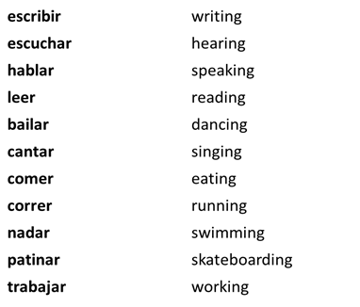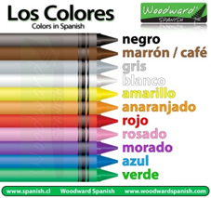
Que te gusta hacer: Me gusta bailar y me gusta cantar.
Y a ti? Me gusta leer, trabajar y escribir.
Preguntas personales:
1) De dónde eres? Yo soy de… 2) Como te llamas? Me llamo… 3) Como estas? Yo estoy 4) Como eres? Yo soy 5) Cual es tu color favorito? Mi color favorito es…6) Cual es tu número favorito? Mi número favorito es… 7) Cual es tu mes favorito? Mi mes favorito es… 8) Cual es tu estación favorita? Mi estación favorita es… 9) Cual es tu dia favorito? Mi dia favorito es… 10) Que te gusta hacer? Me gusta…
Ejercicio 1: Individually, create a personal presentation. Choose a presentation program such as prezi, google slides, voicethread.com or any of your choice.
-Choose 10 answers to the questions above (preguntas personales) then create a personal presentation describing yourself, include a picture in every slide (do not include your own picture. You can use a stick figure or a picture from the web).
-Last slide: References: Picture retrieved from …
-Use your imagination to create the sentences
-Upload your project to: http://padlet.com/sandramar0620/syxye4ny11tr

